**Controle Pessoal de Empréstimos**

Desenvolvido com AngularJS e Bootstrap

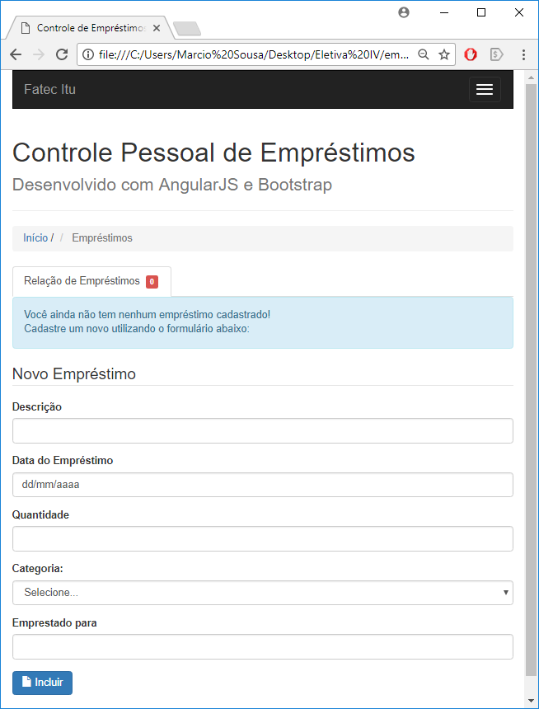

# HTML

<!DOCTYPE html>

<html lang="pt-br">

<head>

    <meta charset="utf-8">

    <meta name="viewport" content="width=device-width, initial-scale=1">

    <title>Controle de Empréstimos</title>

    <meta name="description" content="Controle de Empréstimos com AngularJS e Bootstrap">

    <meta name="author" content="Fatec Itu">

    <!-- o layout com Bootstrap foi gerado através do site http://www.layoutit.com/ -->

    <!-- Carregando o bootstrap -->

    <link rel="stylesheet" href="https://maxcdn.bootstrapcdn.com/bootstrap/3.3.5/css/bootstrap.min.css">

    <!-- Carregando o AngularJS do Google CDN -->

    <script src="https://ajax.googleapis.com/ajax/libs/angularjs/1.4.3/angular.min.js"></script>

    <script src="js/emprestimos.js"></script>

    <!-- Carregando o CSS do projeto -->

    <link rel="stylesheet" href="css/estilo.css" />

    <!-- Troca ícones -->

    <link href="https://maxcdn.bootstrapcdn.com/font-awesome/4.7.0/css/font-awesome.min.css"

    rel="stylesheet" integrity="sha384-wvfXpqpZZVQGK6TAh5PVlGOfQNHSoD2xbE+QkPxCAFlNEevoEH3Sl0sibVcOQVnN"

     crossorigin="anonymous">

</head>

<body ng-app="meusEmprestimos" ng-controller="EmprestimoController">

    <div class="container-fluid">

        <div class="row">

            <div class="col-md-12">

                <nav class="navbar navbar-default navbar-inverse" role="navigation">

                    <div class="navbar-header">

                        <button type="button" class="navbar-toggle" data-toggle="collapse" data-target="#bs-example-navbar-collapse-1">

                            <span class="sr-only">Navegação</span>

                            <span class="icon-bar"></span>

                            <span class="icon-bar"></span>

                            <span class="icon-bar"></span>

                        </button>

                        <a class="navbar-brand" href="#">Fatec Itu</a>

                    </div>

                    <div class="collapse navbar-collapse" id="bs-example-navbar-collapse-1">

                        <ul class="nav navbar-nav navbar-right">

                            <li>

                                <a href="#">Sobre</a>

                            </li>

                        </ul>

                    </div>

                </nav>

                <div class="page-header">

                    <h1>

                        Controle Pessoal de Empréstimos

                        <small>Desenvolvido com AngularJS e Bootstrap</small>

                    </h1>

                </div>

                <ul class="breadcrumb">

                    <li>

                        <a href="#">Início</a>

                        <span class="divider">/</span>

                    </li>

                    <li class="active">

                        Empréstimos

                    </li>

                </ul>

                <ul class="nav nav-tabs">

                    <li class="active">

                        <a href="#">Relação de Empréstimos&nbsp;

                            <span class="label label-danger label-as-badge">

                                {{emprestimos.length}}

                            </span>

                        </a>

                    </li>

                    <li class="active" ng-show="emprestimo.length > 0">

                        <a href="">

                            <p class="text-info">Filtro</p>

                            <form>

                                <input type="search" name="filtro" ng-model="buscaTexto" size="35" placeholder="Buscar por Descrição ou Responsável" />

                            </form>

                        </a>

                    </li>

                </ul>

                <div class="alert alert-info" ng-hide="emprestimos.length > 0">

                    <p class="text-info">

                        Você ainda não tem nenhum empréstimo cadastrado!

                        <br> Cadastre um novo utilizando o formulário abaixo:

                    </p>

                </div>

                <div class="table-responsive" ng-show="emprestimos.length > 0" ng-init="campo='descricao'; ordem=true">

                    {{campo}} {{ordem}}

                    <table class="table table-hover table-condensed table-bordered">

                        <thead>

                            <tr class="success">

                                <th>Finalizado?</th>

                                <th>

                                    <a href="" ng-click="campo='descricao'; ordem=!ordem">

                                        Descriçao

                                        <i class="fa fa-caret-down" ng-show="campo === 'descricao' && !ordem"></i>

                                        <i class="fa fa-caret-up" ng-show="campo === 'descricao' && ordem"></i>

                                    </a>

                                </th>

                                <th>Data do Empréstimo</th>

                                <th>

                                    <a href="" ng-click="campo='quantidade'; ordem=!ordem">

                                        Quantidade

                                        <i class="fa fa-caret-down" ng-show="campo === 'quantidade' && !ordem"></i>

                                        <i class="fa fa-caret-up" ng-show="campo === 'quantidade' && ordem"></i>

                                    </a>

                                </th>

                                <th>Categoria</th>

                                <th>Emprestado para</th>

                            </tr>

                            <tr class="info">

                                <td colspan="6"> Emprestimos a baixar: {{baixar()}} de um total de {{emprestimos.length}}</td>

                            </tr>

                        </thead>

                        <tbody>

                            <tr ng-repeat="emprestimo in emprestimos |orderBy:campo:ordem | filter:buscaTexto" ng-class="{finalizado: emprestimo.finalizado === true}">

                                <td>

                                    <input type="checkbox" ng-model="emprestimo.finalizado">

                                </td>

                                <td>{{ emprestimo.descricao}}</td>

                                <td>{{ emprestimo.data | date:'dd/MM/yyyy'}}</td>

                                <td>{{ emprestimo.quantidade }}</td>

                                <td>{{ emprestimo.categoria }}</td>

                                <td>{{ emprestimo.para }}</td>

                            </tr>

                        </tbody>

                    </table>

                </div>

                <div class="well" ng-show="baixar()>0">

                    <a href="" ng-click="baixaEncerrado()" class="btn btn-lg btn-danger">

                        <i class="fa fa-ban"></i>

                        <span class="glyphicon glyphicon-trash"></span> Remover Encerrados

                    </a>

                </div>

                <form class="form-horizontal" role="form" ng-submit="adicionaEmprestimo(emprestimo)">

                    <fieldset>

                        <legend>Novo Empréstimo</legend>

                        <div class="form-group">

                            <label for="descricao" class="col-sm-2 control-label">

                                Descrição

                            </label>

                            <div class="col-sm-10">

                                <input type="text" class="form-control" id="descricao" ng-model="emprestimo.descricao" required />

                            </div>

                        </div>

                        <div class="form-group">

                            <label for="emprestimo" class="col-sm-2 control-label">

                                Data do Empréstimo

                            </label>

                            <div class="col-sm-10">

                                <input type="date" class="form-control" id="emprestimo" ng-model="emprestimo.data" required />

                            </div>

                        </div>

                        <div class="form-group">

                            <label for="quantidade" class="col-sm-2 control-label">

                                Quantidade

                            </label>

                            <div class="col-sm-10">

                                <input type="number" min="0" class="form-control" id="quantidade" ng-model="emprestimo.quantidade" required/>

                            </div>

                        </div>

                        <div class="form-group">

                            <label for="categoria" class="col-sm-2 control-label">Categoria:</label>

                            <div class="col-sm-10">

                                <select class="form-control" id="categoria" ng-model="emprestimo.categoria" required>

                                    <option value="livro">Livros</option>

                                    <option value="cddvd">CD/DVD</option>

                                    <option value="roupas">Roupas</option>

                                    <option value="outros">Outros</option>

                                    <option value="" selected>Selecione...</option>

                                </select>

                            </div>

                        </div>

                        <div class="form-group">

                            <label for="para" class="col-sm-2 control-label">

                                Emprestado para

                            </label>

                            <div class="col-sm-10">

                                <input type="text" class="form-control" id="para" ng-model="emprestimo.para" required />

                            </div>

                        </div>

                        <div class="form-group">

                            <div class="col-sm-offset-2 col-sm-10">

                                <button type="submit" class="btn btn-primary">

                                    <span class="glyphicon glyphicon-file"></span> Incluir</button>

                            </div>

                        </div>

                    </fieldset>

                </form>

            </div>

        </div>

    </div>

    <div id="footer">

        <div class="container">

            <p class="muted credit">Fatec Itu &copy; - Disciplina Eletiva IV - Curso ADS</p>

        </div>

    </div>

</body>

</html>

# JS

var app = angular.module ("meusEmprestimos", []);

app.controller('EmprestimoController', ['$scope',

function($scope) {

// Carrega os dados salvos

$scope.dadosSalvos = localStorage.getItem('emprestimos');

    $scope.emprestimos = ($scope.dadosSalvos!==null) ? JSON.parse($scope.dadosSalvos) : [];

    // Inclui o Emprestimo

$scope.adicionaEmprestimo = function(emprestimo) {

            $scope.emprestimos.push(emprestimo);

localStorage.setItem('emprestimos', angular.toJson($scope.emprestimos));

$scope.emprestimo = {};

        };

// Contar Empréstimos a Baixar

$scope.baixar = function(){

var contador = 0;

angular.forEach($scope.emprestimos, function(emprestimo){

contador += emprestimo.finalizado ? 1 : 0;

});

return contador;

};

//Baixa Empréstimos Encerrados

$scope.baixaEncerrado = function(){

//copiando o array de registros para um array temporário

var tempEmprestimos = $scope.emprestimos;

//inicializando o array vazio

$scope.emprestimos = [];

//Percorrendo todos os registros e adicionando apeas os não finalizados

angular.forEach(tempEmprestimos, function(emprestimo){

if(!emprestimo.finalizado) //note a negação!

$scope.emprestimos.push(emprestimo);

});

//Salvando o Array

localStorage.setItem('emprestimos', angular.toJson($scope.emprestimos));

};

}]);

# CSS

/* Css do Projeto

Created on : 14/03/2018, 15:09:05

Author : Marcio Sousa - Gti-Ads

*/

/* Criando uma classe CSS*/

.finalizado{

text-decoration: line-through; /*Traço*/

color: gray;

background: #CCCCCC; /*Cinza Claro*/

}